R_Sort
(Radix sort)
Table of Contents
Preliminary Specification for R-Sort 3
Updated Design Specification for R-Sort 3
Behavioral Design 3
Simulation of Behavioral Design 3
High Level Synthesis 4
Some notes about the states 4
IDLE 4
INPUT 4
BUCKETIZE 4
MERGE 4
DONE 4
Simulation of Structural Design 5
Logic Sythesis to Gate Level 5
Testability Improvement 5
Test Pattern Generation 6
Appendix A – Code for behavioral specification
Appendix B – Simulation results of the behavioral specification
Appendix C – CDFG
Appendix D – Initial scheduling based on the CDFG
Appendix E – Optimized Scheduling of the CDFG
Appendix F – RTL Data Path Structure
Appendix G – VHDL code involved in the structural design
Appendix H – Simulation of the structural design

Preliminary Specification for R-Sort
The R-sorter (R_sort) component takes an array A of unsigned integers as input and outputs the numbers as an array S sorted by value. There is also a data-ready output DR, which is set to 1 only when the data in output array S is sorted. Other inputs are CLK and RST, for clock and reset signal respectively. The reset signal is asynchronous. Below, in Figure 1, is a schematic overview of the R_sort component.

Figure 1: R_sort component overview
R_sort
A
CLK
RST
S
DR
L
L

Internally, the radix sort algorithm is used for sorting.

Updated Design Specification for R-Sort
The specification for the R-Sort component (R_Sort), was changed during the high level synthesis so that the sorting starts after the RST signal become low after being high for one clock cycle. Thereafter, the unsorted values in the array A are loaded one by one instead of all at the same time. When the sorting is done, the DR signal goes high for one cycle per sorted number that is being outputted.

Behavioral Design
For the specification of the behavioral design in VHDL code, see Appendix A that contains code for the r_sort component as well as a testbench and a clock generator.

Simulation of Behavioral Design
For a screenshot of the behavioral simulation in ModelSim, see appendix B.

High Level Synthesis
In order to convert the high level description into an RTL design a number of steps were performed.
- First a CDFG graph (Appendix C) was constructed.
- From this graph an initial scheduling was performed (Appendix D).
- This schedule was then optimized (Appendix E) by extracting parallelism due to the fact that it would be implemented using a synchronous design.
- When the scheduling was finished a RTL Data Path Structure (Appendix F) was created, while performing resource allocation.
- After the Data Path Structure had been created a controller was implemented using a FSM.

The code for the structural design, the state machine, the primitives used as well as the testbench are available as Appendix G.

Some notes about the states

IDLE
The IDLE state is used when the reset signal is high. As soon as the reset signal goes low the component will go to the INPUT state.

INPUT
In the INPUT state values are read from the input port and sorted directly into the two buckets based on the least significant bit. Thus this is merely a specialization of the BUCKETIZE state. This state could have been avoided if we had moved the counter for the significant bit into the FSM.

BUCKETIZE
In the BUCKETIZE state values are read from the input port and sorted directly into the two buckets based on the least significant bit.

MERGE
When in the MERGE states the component first checks if there is any numbers in bucket 0, if there are numbers there they are moved to the temp memory one by one. After that the same procedure is executed for bucket 1.
One optimization done is that the merging from bucket 1 is skipped if bucket 0 contained all the numbers .
When the numbers have been divided into the bucket for the last time, they are transferred to the output register instead of the temp memory.

DONE
This state's only purpose is to prevent the component from starting to read in numbers and start to execute as son as the numbers have been sorted and outputted. The component waits here until the reset goes high.

Simulation of Structural Design
For a screenshot of the simulation of the structural design in ModelSim, see Appendix H.

Logic Sythesis to Gate Level
At this stage, the Leonardo Spectrum tool was used. No output screenshots were required for this part.

Testability Improvement
Now, the tool DFTAdvisor was used to increase testability by replacing flip-flops by scan-cells. This operation increases the testability since the values of scan-cells can be read while the clock is stopped leading to many more values being measurable when performing testing. In Figure 3 below, we see that 100% scan-cells were identified.
Initially most of the scan cells could not be identified, but after some rewriting of the code to follow DFTAdvisor's design rules all the scan cells could be found. This required quite a lot of time, but if the design rules had been known at the beginning this could have been avoided. So we would recommend anybody doing a real design to first get to know the design rules of the synthesis tools.
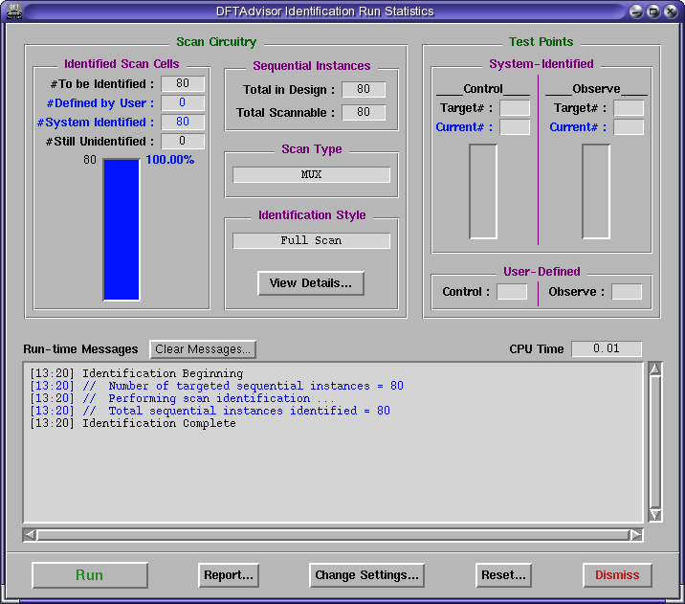Figure 2: Screenshot of DFT Advisor scan cell identification results

Test Pattern Generation
The tool FlexTest was used to generate test-patterns. As can be seen from Figure 3 and Figure 4, the testability increased from 0% to over 91%, while the ATPG effectiveness increased from roughly 9% to 94%, indicating that the scan-cells greatly improved the testability. In our case the test pattern generation failed for the structural design without scan cells, probably because there were some design rules not fallowed. Even if the test pattern generation would have succeeded much lover test coverage would have been expected.

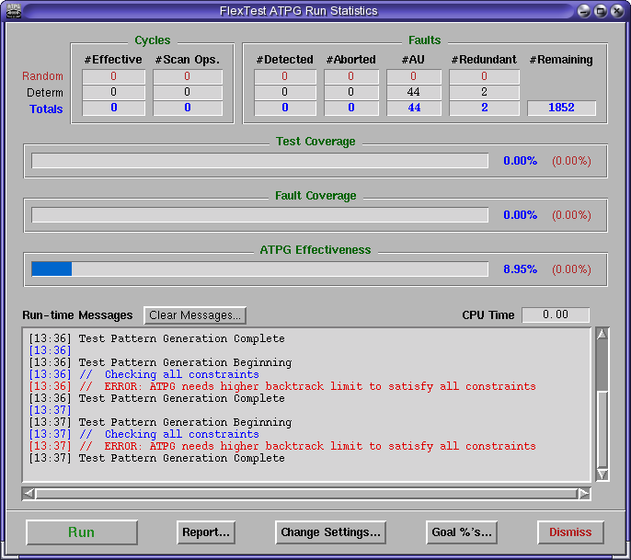Figure 3: FlexTest test pattern generation without scan cell insertion

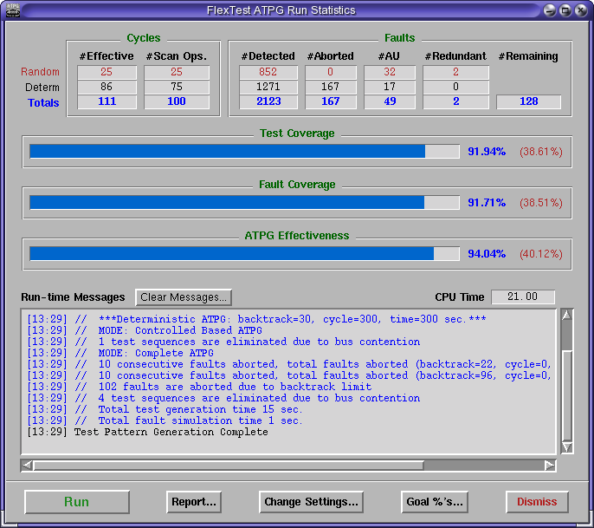Figure 4: FlexTest test pattern generation with scan cell insertion

Appendix A – Code for behavioral specification

Appendix B – Simulation results of the behavioral specification

Appendix C – CDFG

Appendix D – Initial scheduling based on the CDFG

Appendix E – Optimized Scheduling of the CDFG

Appendix F – RTL Data Path Structure

Appendix G – VHDL code involved in the structural design

Appendix H – Simulation of the structural design

